**Switch Window Commands:**

Some web applications have many frames or multiple windows. Selenium WebDriver assigns an alphanumeric id to each window as soon as the WebDriver object is instantiated. This unique alphanumeric id is called window handle. Selenium uses this unique id to switch control among several windows.

**getWindowHandle()** - return a string value and it returns the Window handle of current focused browser window.

Session of selenium WebDriver we mean the duration from the time we instantiate a WebDriver instance to the time we kill it via WebDriver.Quit.

**getWindowHandles()** - returns a set<String> of all Window handles of all the browsers that were opened in the session.

**switchTo().window("windowName")** – By default the focus is always on the Parent window, In order to shift focus from Parent Window to any child window we have to use the above command on WebDriver.

for (String handle : driver.getWindowHandles()) {

driver.switchTo().window(handle);

}

Iterator can also be used.

**import** java.util.Set;

**import** org.openqa.selenium.By;

**import** org.openqa.selenium.WebDriver;

**import** org.openqa.selenium.WebElement;

**import** org.openqa.selenium.chrome.ChromeDriver;

**public** **class** WindowsBrowsersDemo {

**public** **static** **void** main(String[] args) **throws** InterruptedException {

WebDriver driver = **new** ChromeDriver();

// Maximize window

driver.manage().window().maximize();

driver.get("https://demoqa.com/browser-windows");

String parentWindowHandle = driver.getWindowHandle();

System.***out***.println("Parent window's handle -> " + parentWindowHandle);

WebElement clickElement = driver.findElement(By.*id*("windowButton"));

**for**(**int** i = 0; i < 3; i++)

{

clickElement.click();

Thread.*sleep*(3000);

}

Set<String> allWindowHandles = driver.getWindowHandles();

**for**(String handle : allWindowHandles)

{

System.***out***.println("Window handle - > " + handle);

driver.switchTo().window(handle); //Switch to the desired window first and then execute commands using driver

System.***out***.println("Navigating to google.com");

driver.get("http://google.com");

}

driver.switchTo().window(parentWindowHandle);

driver.get("https://www.cleartrip.com/");

String parentWindowHandle1 = driver.getWindowHandle();

System.***out***.println("default window's handle -> " + parentWindowHandle1);

}

}

Parent window's handle -> B820C0F7BBBA2F49D6E2939C0C880722

Window handle - > B820C0F7BBBA2F49D6E2939C0C880722

Navigating to google.com

Window handle - > 6F090972C940BC6A46F338C1C933C8CC

Navigating to google.com

Window handle - > 9152E66E2982236FB3CDCDB647C06E23

Navigating to google.com

Window handle - > F13159D7DDD2CDC98BE9DFFF9853D957

Navigating to google.com

default window's handle -> B820C0F7BBBA2F49D6E2939C0C880722

Parent window – cleartrip

3 child windows – Google.com

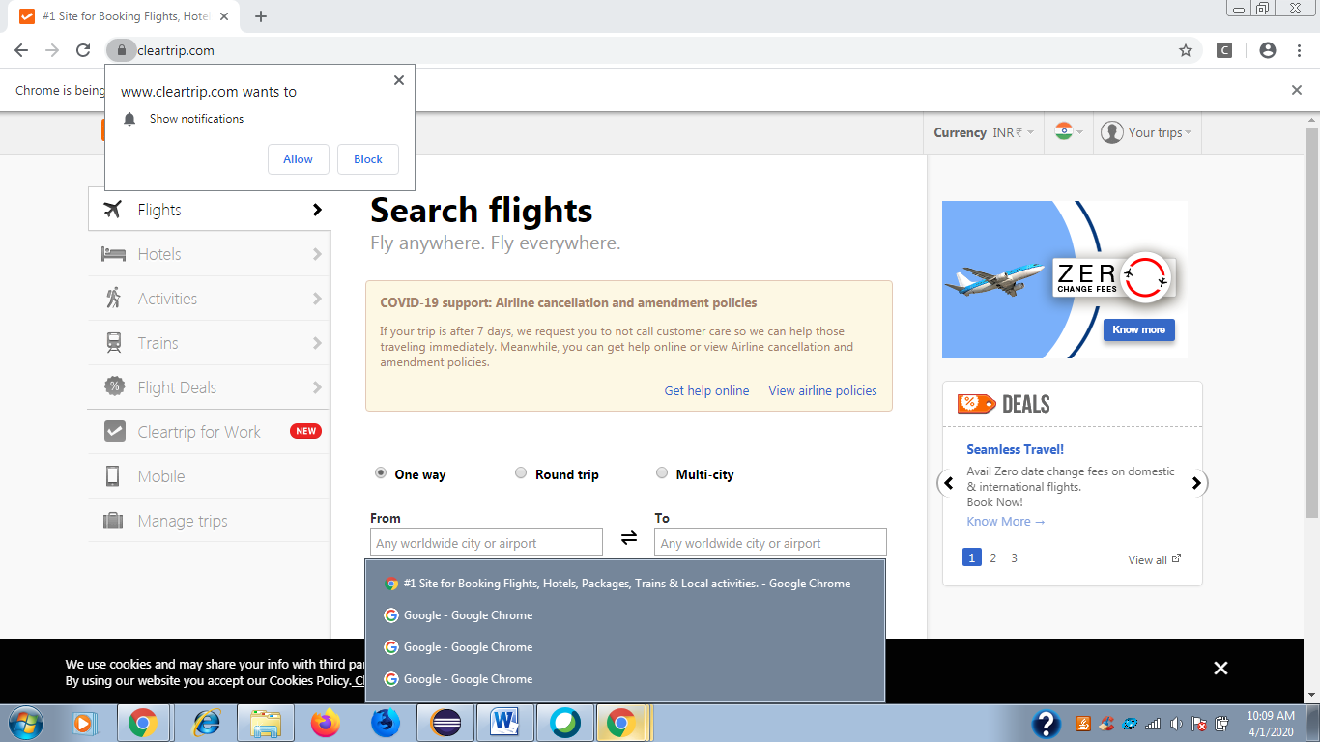

Switch windows:

<https://stqatools.com/selenium-tab/>

<https://www.toolsqa.com/selenium-webdriver/handling-multiple-browsers-in-selenium-webdriver/>

<https://demoqa.com/automation-practice-switch-windows/>

<https://www.softwaretestingmaterial.com/handle-multiple-windows-using-selenium-webdriver/>

<http://learn-automation.com/handle-multiple-windows-in-selenium-webdriver/>

<https://www.toolsqa.com/selenium-webdriver/switch-commands/>

<http://design-interviews.blogspot.com/2014/11/switching-between-tabs-in-same-browser-window.html> - sample script

<https://stackoverflow.com/questions/12729265/switch-tabs-using-selenium-webdriver-with-java>

<http://www.software-testing-tutorials-automation.com/2015/02/how-to-open-tab-and-switching-between.html> - For switching between tabs of browser

<https://www.edureka.co/community/52549/switch-between-tabs-browser-titles-each-tab-using-selenium> - using JavascriptExecutor

<https://dzone.com/articles/handling-multiple-browser-tabs-with-selenium-autom>

package Testing_Pack;

import java.util.concurrent.TimeUnit;

import org.openqa.selenium.By;

import org.openqa.selenium.Keys;

import org.openqa.selenium.WebDriver;

import org.openqa.selenium.firefox.FirefoxDriver;

import org.testng.annotations.BeforeTest;

import org.testng.annotations.Test;

public class Tabs {

WebDriver driver;

@BeforeTest

public void setup() throws Exception {

driver = new FirefoxDriver();

driver.manage().window().maximize();

driver.manage().timeouts().implicitlyWait(5, TimeUnit.SECONDS);

driver.get("http://only-testing-blog.blogspot.com/2014/04/calc.html");

}

@Test

public void openTab() {

**//Open tab 2 using CTRL + t keys.**

driver.findElement(By.cssSelector("body")).sendKeys(Keys.CONTROL +"t");

**//Open URL In 2nd tab.**

driver.get("http://only-testing-blog.blogspot.com/2014/05/form.html");

**//Call switchToTab() function to switch to 1st tab**

switchToTab();

**//perform required actions on tab 1.**

driver.findElement(By.xpath("//input[@id='6']")).click();

driver.findElement(By.xpath("//input[@id='plus']"));

driver.findElement(By.xpath("//input[@id='3']"));

driver.findElement(By.xpath("//input[@id='equals']"));

**//Call switchToTab() function to switch to 2nd tab.**

switchToTab();

**//perform required actions on tab 2.**

driver.findElement(By.xpath("//input[@name='FirstName']")).sendKeys("hi");

driver.findElement(By.xpath("//input[@name='LastName']")).sendKeys("test");

**//Call switchToTab() function to switch to 1st tab**

switchToTab();

**//perform required actions on tab 1.**

String str = driver.findElement(By.xpath("//input[@id='Resultbox']")).getAttribute("value");

System.out.println("Sum result Is -> "+str);

}

public void switchToTab() {

**//Switching between tabs using CTRL + tab keys.**

driver.findElement(By.cssSelector("body")).sendKeys(Keys.CONTROL +"\t");

**//Switch to current selected tab's content.**

driver.switchTo().defaultContent();

}

}